| **Test Name** | | | Game rolls test:  Spade is never drawn, out of six possible symbols, all five symbols are randomly select except spade | | | |
| --- | --- | --- | --- | --- | --- | --- |
| **Use Case Tested:** | | | Play Game | | | |
| **Test Description:** | | | Tests that each roll is producing new results, and we don’t get the same result every roll, and every game, in each run of Main.java. | | | |
| **Pre-conditions** | | | No pre-conditions (first bug to be investigated and resolved, as it is a pre-requisite to properly replicate the other bugs). | | | |
| **Post-conditions** | | | Not every roll is identical. | | | |
| **Notes:** | |  | | | | |
| **Result (Pass/Fail/Warning/Incomplete)** | |  | | | | |
|  | **TEST STEP** | | | **EXPECTED TEST RESULTS** | P | F |
|  | RunDiceTest.java | | | Console opens and results for 100 games are displayed in it. Only the rolls are shown (i.e. only lines of the form, “Rolled DIE1, DIE2, DIE3” where DIE1, DIE2, and DIE3 are one of the available faces CROWN, ANCHOR, , HEART, DIAMOND, CLUB), no Spade is rolled. |  |  |
|  | Look at each individual line | | | There are at minimum two different rolls. |  |  |
|  | Repeat Steps 1-2 twice (for three runs total). | | | Same as Steps 1-2. |  |  |

**BUG 5: Game Rolls Test**

|  |  |  |  |  |  |
| --- | --- | --- | --- | --- | --- |
| **Test Data Table** | | | | | |
|  | **1** | **2** | **3** | **4** | **5** |
| N/A |  |  |  |  |  |

# Results

## Run 1

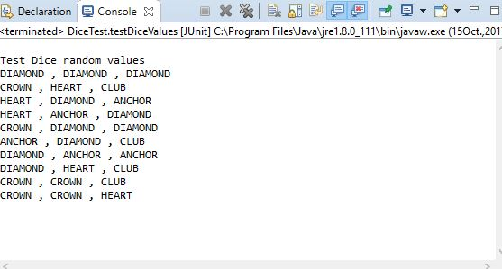

## Run 2

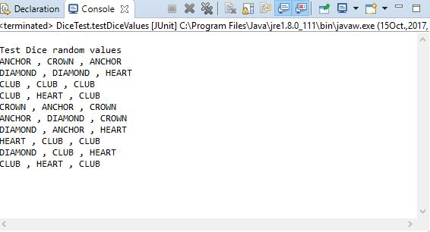

## Run 3

